FOR IMMEDIATE RELEASE
Media Contact: Jordan Holt
jordan@pierce-pr.com | 817-975-3847

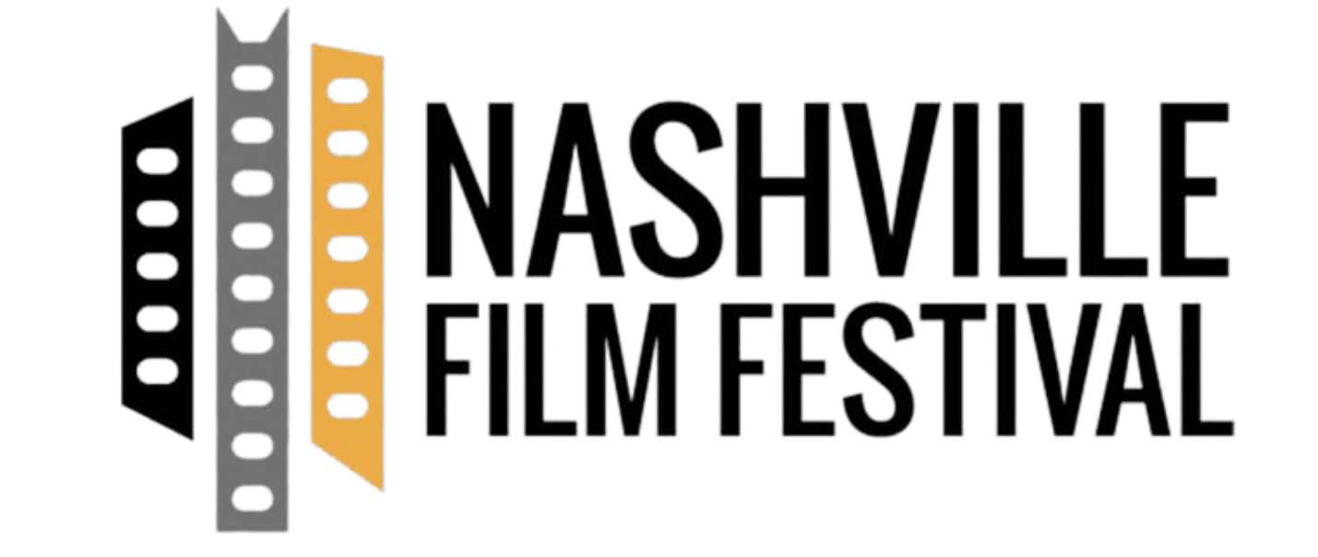

Nashville Film Festival Unveils KISS OF THE SPIDER WOMAN as Closing Night Presentation, Film’s Lead Tonatiuh Honored With Rising Star Award; JOHN CANDY: I LIKE ME Set for Centerpiece

The 56th annual festival adds to lineup of impressive programming with two captivating special presentations

Nashville, Tenn. (August 20, 2025) - The Nashville Film Festival (NashFilm), a week-long celebration of film, music and culture, today announced the highly anticipated closing and centerpiece presentations audiences can’t miss at the 56th annual event. To close this year’s lineup, the Festival will screen “KISS OF THE SPIDER WOMAN,” a musical thriller based on the book and Tony-award winning musical of the same name, following a political prisoner sharing a cell with a window dresser. The film’s lead, Tonatiuh will accept the Rising Star Award after a Q&A post-screening. “JOHN CANDY: I LIKE ME,” follows the legacy and impact of the famous comedian John Candy as the centerpiece film.

“These selections offer some of the most anticipated, entertaining and emotionally impactful films of the season," said Lauren Thelen, NashFilm’s Programming Director. “Each film, spanning heartfelt, inspiring and deeply resonant stories, represents the compelling work in cinema today. We’re thrilled to bring these films to our Nashville audiences, setting the tone for an unforgettable week.”

KISS OF THE SPIDER WOMAN (Roadside Attractions) | Directed by Bill Condon | Diego Luna, Tonatiuh and Jennifer Lopez
Closing out this year’s festival, "KISS OF THE SPIDER WOMAN” showcases a dazzling Technicolor-hued fantasy. Valentín, a political prisoner, shares a cell with Molina, a window dresser convicted of public indecency. The two form an unlikely bond as Molina recounts the plot of a Hollywood musical starring his favorite silver screen diva, Ingrid Luna. Tonatiuh will be in attendance to receive the Rising Star Award and participate in a special Q&A after the screening on September 24 at 6 p.m.

JOHN CANDY: I LIKE ME (Amazon MGM Studios) | Directed by Colin Hanks | Starring John Candy
As the centerpiece feature, “JOHN CANDY: I LIKE ME," director Colin Hanks and lifelong John Candy fan and producer Ryan Reynolds, explore the life and legacy of the Canadian comedic icon, charting his rise to fame while battling personal ghosts and the pressures of Hollywood. The film documents Candy’s on- and off-camera existence, featuring never-before-seen home videos, intimate access to his family and candid recollections from collaborators to paint a bigger picture of one of the brightest stars of the ’70s, ’80s and ’90s. “JOHN CANDY: I LIKE ME” will screen on September 20 at 8:00 p.m.

Alongside these special presentations, the festival kicks off with an opening night celebration at Urban Cowboy Bar in The Arcade on Sept. 18. It wraps with a grand closing night party at Electric Jane on Sept. 24, bringing all festival goers together for one unforgettable evening to cap off the event.

The full slate of films and programs selected for the 56th Nashville Film Festival has been previously announced. VIP Badges are on sale now for the 2025 Nashville Film Festival. For more information on the 56th Festival lineup and to purchase passes, visit www.nashvillefilmfestival.org.

About the Nashville Film Festival
The Nashville Film Festival (NashFilm) is a globally recognized nonprofit organization and cultural event presenting the best in world cinema, American independent films and documentaries by veteran masters, up-and-coming directors, and first-time filmmakers. With Academy Award® qualifying status, the Nashville Film Festival celebrates innovation, music and the many voices of the human spirit through the art of film. Originally founded in 1969, the Nashville Film Festival is one of the first film festivals in the United States and will host its 56th festival from September 18-24, 2025. For more information, visit www.nashfilm.org.

# # #

